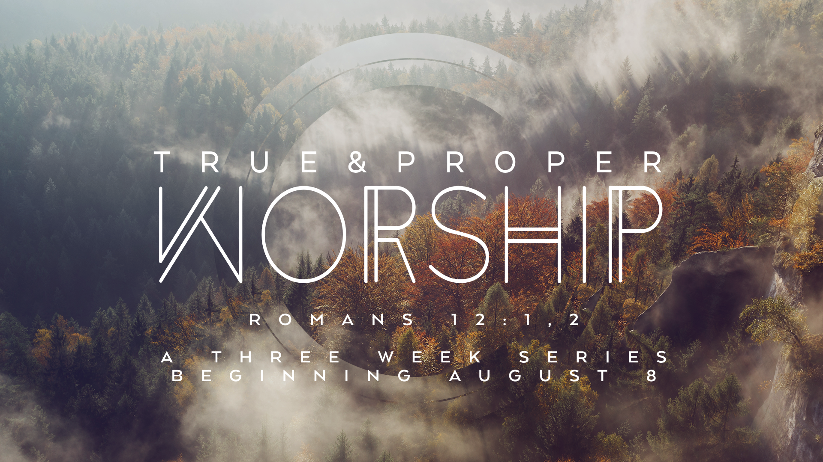
True and Proper Worship
Lesson 1 – The “Who” of Our Worship
“I beseech you therefore, brethren, by the mercies of God, that ye present your bodies a living sacrifice, holy, acceptable unto God, which is your reasonable service (your true and proper worship).”
Romans 12:1

Christian worship might be one of the most talked about and least understood topics of the church. Worship is the very core purpose of the church, therefore it is vital we have a proper understanding from the Word of God.
Romans 12:1 defines the purpose of the individual Christian life. The word “service” is translated from the greek work “latriah” meaning the service and worship of God.
What is worship? Webster defines worship as “reverence offered a divine being or supernatural power: an act of expressing reverence. Extravagant respect or admiration for or devotion to an object of esteem.”
In the current climate of Christian worship, the conversation generally begins with some form of “__________ is how I like to worship God” or “__________ is how I think we should worship God.”
If this is where the conversation begins, we have started from the wrong point of reference.
The fixed point of reference must be “how does God desire that we worship Him?” To answer this question the child of God needs to have an understanding of what God is like.
Consider a married couple. One of the great things about being married is the ability to get to know one person in an intimate way for the rest of your life. This growing knowledge enables us to learn how to better serve and love him or her daily.
The Word of God teaches that we (the church) are the bride of Christ, and will be married to God for all eternity. (Eph 5:23) (Rev 19:7)
In order to effectively worship God, and devote ourselves to Him it requires the discipline of study. Understanding his person, his being, what brings Him pleasure, what brings Him displeasure?
That is why we begin with the essential first question, “the Who of our worship.”

God Is Spirit
“God is a Spirit: and they that worship Him must worship him in spirit and in truth.”
John 4:24
- What does this mean? – the essence of God, his makeup, is immaterial. Consider (Luke 24:39)
- Although there are many human characteristics designated to God in the Scriptures they only exist to help our finite understanding. Every illustration falls short of the true nature of His glory.
Why does this matter?
True and proper worship only happens when it is does from a right heart of the inner man (John 4:24) Worship is not contingent on a physical location or action, God is Spirit, so we must worship him in spirit.
- To worship in spirit with the right heart means our worship is universal. (1 Corinthians 10:31)
- To worship in spirit, with a right heart means to give our best (Malachi 1:6-10)
- To worship in spirit, with a right heart, means worship must be our priority. (Matthew 5:8)
- To worship in spirit with a right heart means to be zealous in pursuing God. (Jeremiah 29:13)
- To worship in spirit with a right heart means to worship in holiness. (Psalm 66:18)
- To worship in spirit with a right heart means to live peaceably without division. (Matt 5:23-24)

God is a Person
“So God created man in his own image, in the image of God created he him; male and female created he them.”
Genesis 1:27
Because God is a person we can have an intimate relationship with Him. In what ways can we see God’s personhood? We see it in the fact that God demonstrates characteristics of personality such as joy, anger, and consciousness as revealed to us in the Scriptures.
Why does this matter?
- His personhood reminds us that we can get to know God more and more as with any person. (Ephesians 1:17)
- His personhood reminds us that we must develop sensitivity to his person. (Ephesians 4:30) (1 Thessalonians 5:19)
- His personhood reminds us that God is not a tool or an object to be used. (John 17:3)

God is Independent
“God that made the world and all the things therein, seeing that he is the Lord of heaven and earth, dwelleth not in temples made with hands; neither is worshipped with men’s hands, as though he needed anything, seeing he giveth to all life and breath, and all things.”
Acts 17:24-25
“This understanding can enhance our worship of God, because while God has a voluntary relationship to everything, He has a necessary relationship to nothing. In other words, God relates to His creation because He chooses to, not because He needs to. If you show up for worship at your church, that’s good and God is glad to see you. But He will not be worse off if you stay home. He’s not going to panic.”
Tony Evans – Theology You Can Count On
Can we really give to God? There is a sense in which we can’t. We can’t because God is independent, and he is the true giver of all things. We can give only because he has given to us.
Why did God create us?
- For his enjoyment (Zephaniah 3:17) (Colossians 1:16). When we do what God has called us to do, and created us for He takes great pleasure in those things.
Why does this matter?
- Understanding God’s independence reminds us of God’s love for us (Ephesians 3:17-19) (John 3:16)
- Understanding God’s independence reminds us our need to be dependent. (Matthew 18:3,4)

God is Immutable
Immutability means not having the ability to change. Our God is always the same; he is unchangeable in his character.
“Of old hast thou laid the foundation of the earth: and the heavens [are] the work of thy hands.
They shall perish, but thou shalt endure: yea, all of them shall wax old like a garment; as a vesture shalt thou change them, and they shall be changed:
But thou [art] the same, and thy years shall have no end.”
Psalm 102:25-27

For I am the Lord, I change not; therefore ye sons of Jacob are not consumed.”
Malachi 3:6

Change makes it hard to understand one another, that is why is so easy to understand God. He is the same yesterday, today and forever.

What else about God is unchangeable?
- He is unchangeable in his plans (Psalm 33:11)
- He is unchangeable in his promises (Numbers 23:19)

God is Good

“And Jesus said unto him, ‘Why callest thou me good? None is good, save one, that is, God.”
Lueke 18:19

“The goodness of God means that God is the final standard of good, and that all that God is and does is worthy of approval.”
-Wayne Grudem –

- God is the source of Good (James 1:17) (Luke 11:11-13)
- God’s goodness should provoke Christians to Hedonism (1 Timothy 4:4-5) (1 Timothy 6:17) Christians are called to be hedonists in the sense that as we enjoy God’s gifts we focus on the Giver of all good gifts.
- God’s goodness should provoke Christians to worship. (Psalm 107:1) (Psalm 107:8) The believer can give thanks to God even in the greatest difficulty because they know God’s hand and goodness are on it. (Romans 8:29)
- God’s goodness should provoke Christians to good works (Matthew 5:44-45) (Galatians 6:10)

God’s goodness means that he is the standard of all that is good and that everything he does is ultimately good. Understanding this reality should make us seek to enjoy God’s gifts. It will draw us to worship, thanksgiving, and ultimately to practicing good works as children representing the Father.

